Practical No.11
Aim: Use of ping and tracert/trace route, ipconfig, ifconfig commands.
Ping:
Ping command is used to test connection. The ping command is the network utility used to test connectivity between to devices on a network. It also used to check wheather a device or website is reacheable over a network & to major response time.
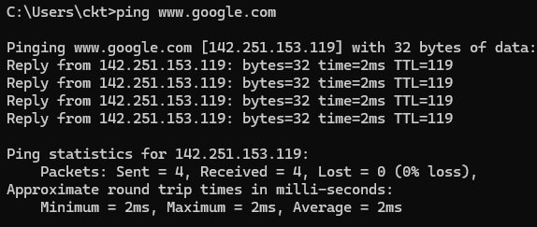

Tracert:
It is used to track the & find the route & majors the delay of packet travelling across a network.
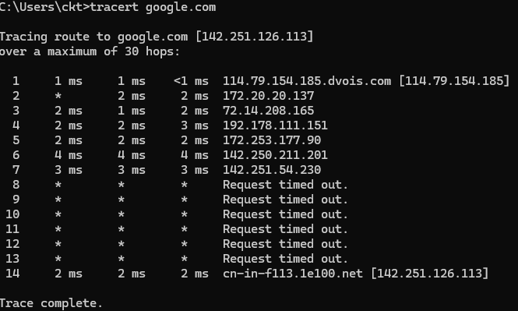
IPconfig:
It is used to find out the IP address that is IPv4 & IPv6 address of the system also used to find out subnet of the syatem.
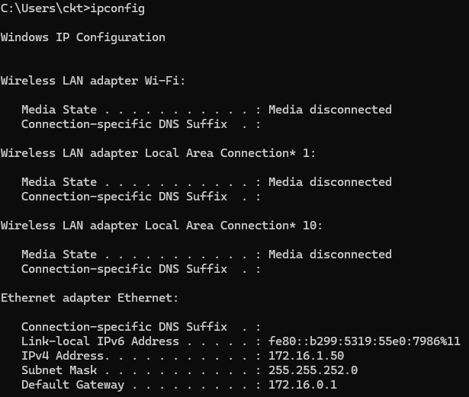

IFconfig:

Practical No.12
Aim: Use of Route and ARP command.
Route:
Route command is used to manage the path that data packets follow in the network. It is also used for display routing table and adding or deleting routes from the network.
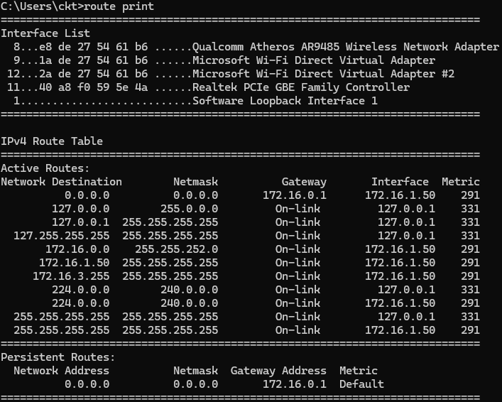
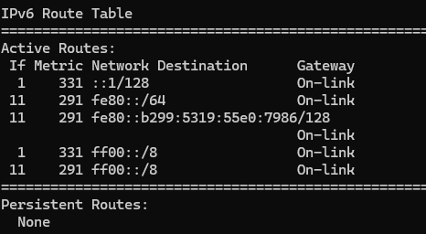

ARP(Address Resolution Protocol):
It is used to find and manage the mack adderss corresponding to an IP adderss in a network when device knows the IP addess but not the mack adderss it sends an ARP request.
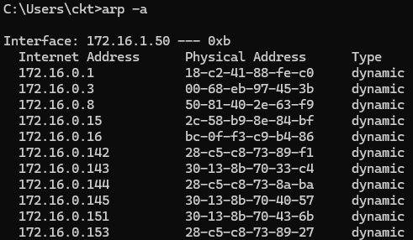

Practical No.13
Aim: Config IP Static Routing.
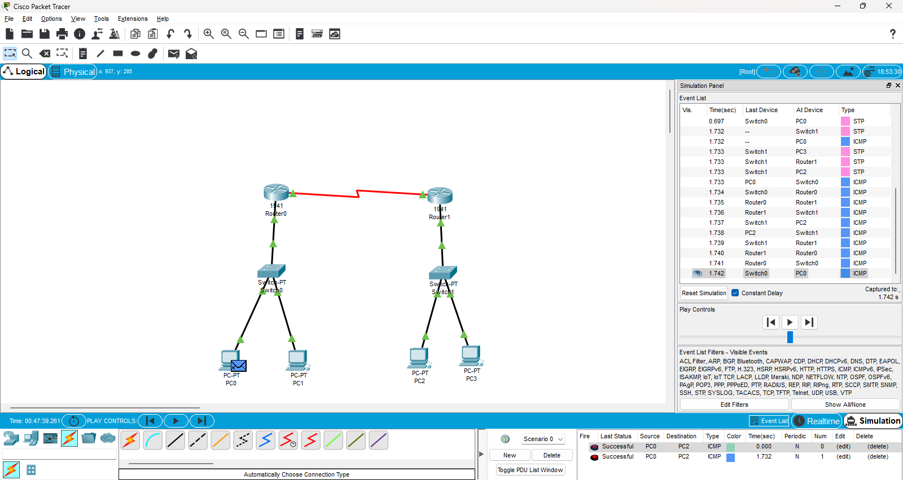
PC Configuration
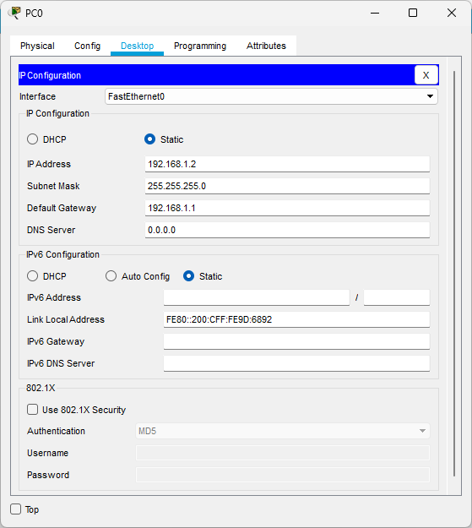
Router Configuration:
A) GigabitEthernet0/0 Configuration
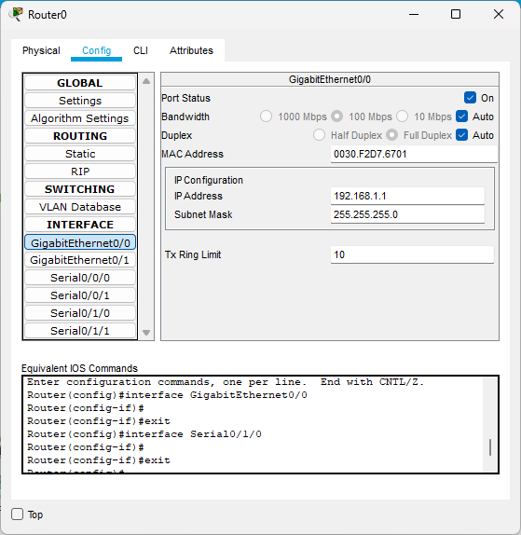
B) Serial0/1/0 Configuration
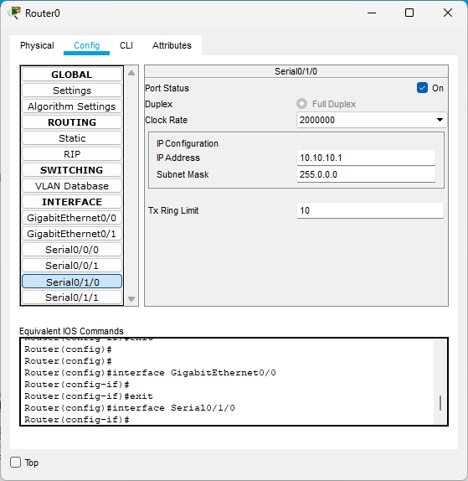
C) Static Configuration
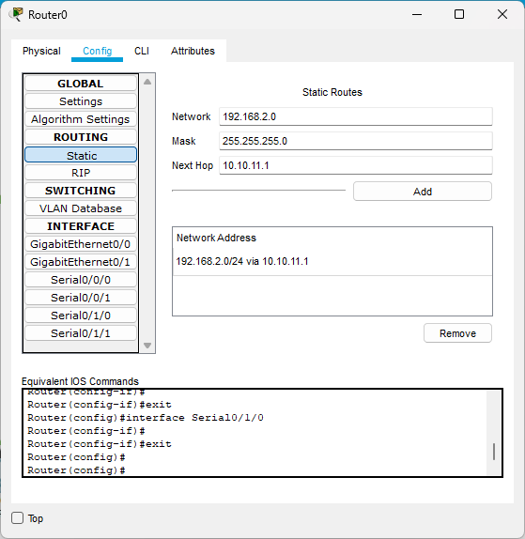
D) Setting Configuration
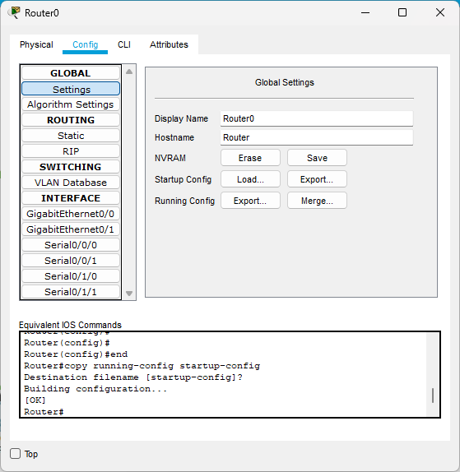
Practical No.14
Aim: Routing Information Protocol (RIP).
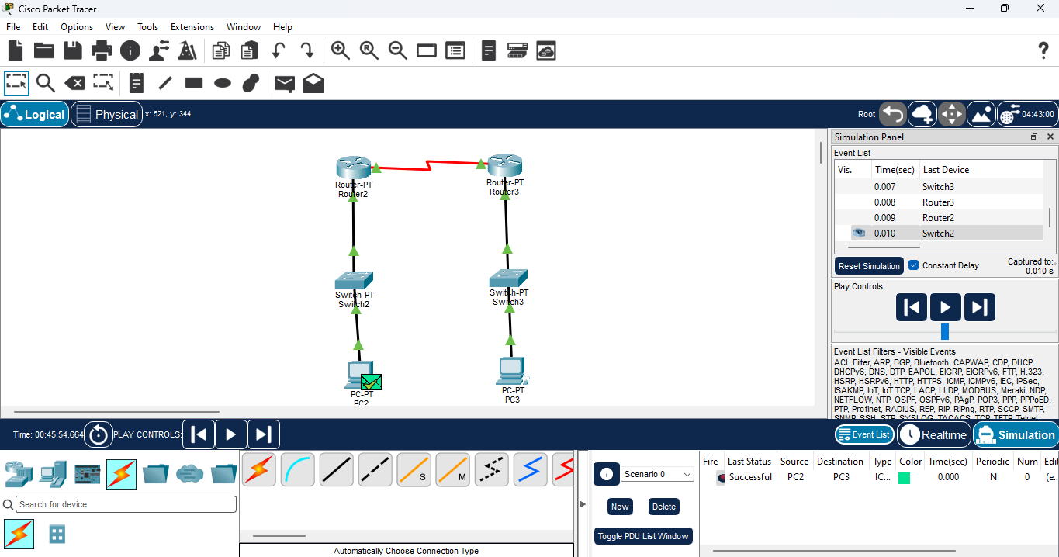
PC Confifuration
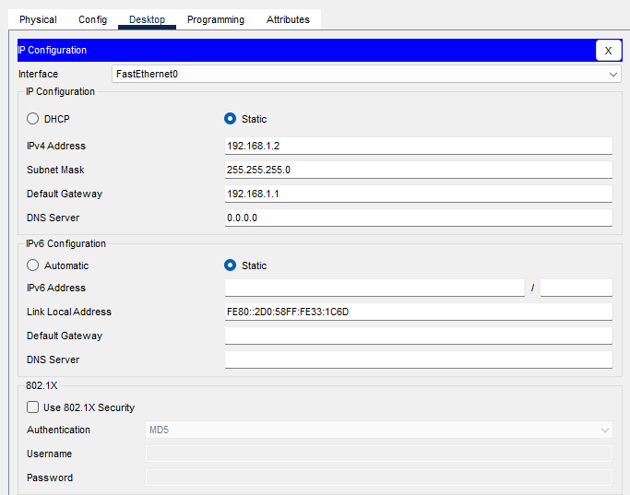
Router Configuration
FastEthernet0/0 (Router 1)
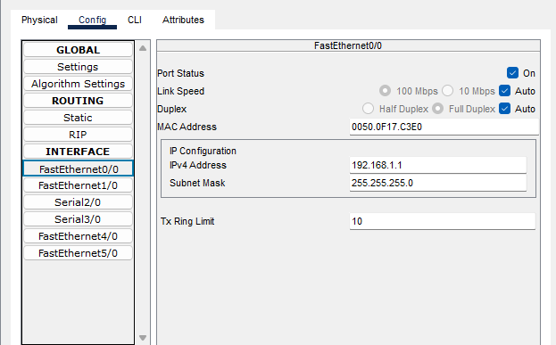
Serial2/0
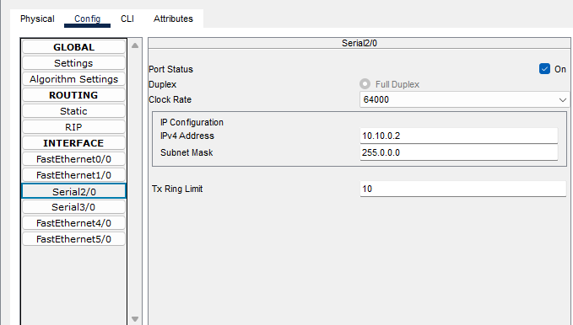

RIP
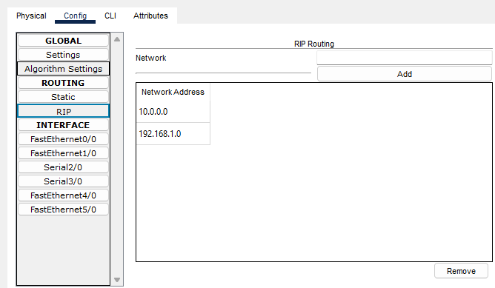
FastEthernet0/0 (Router 2)
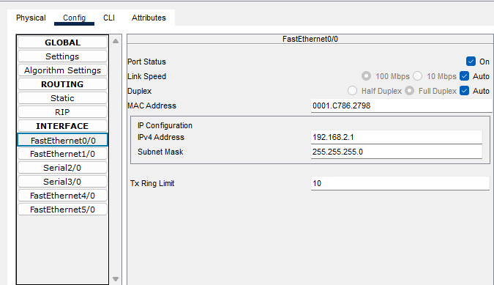

Serial2/0
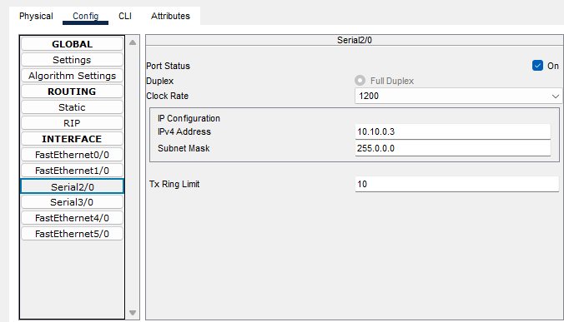
RIP
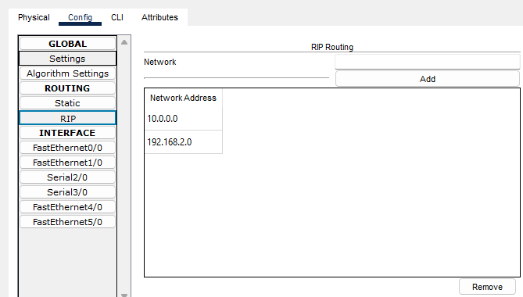

Practical No.15
Aim: Open Shortest Path First.
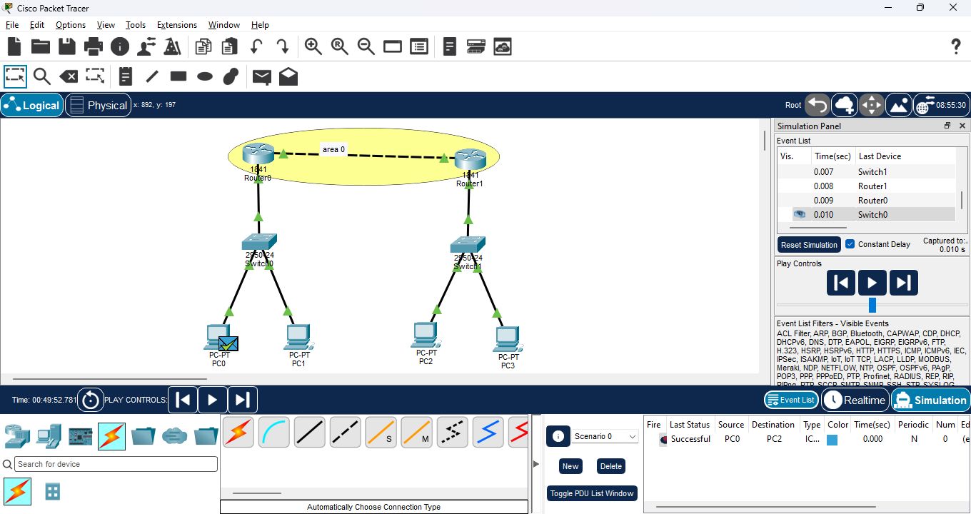
PC Configuration:
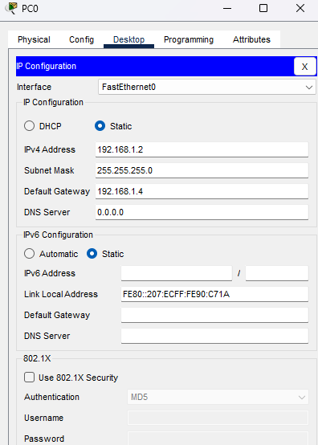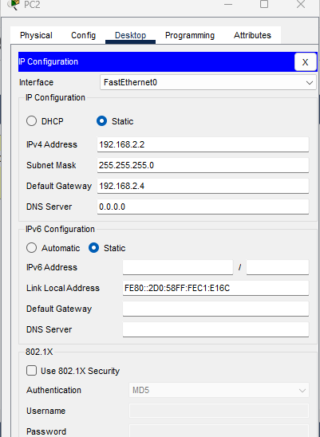
Router Configuration:
FastEthernet0/0 (Router 0)
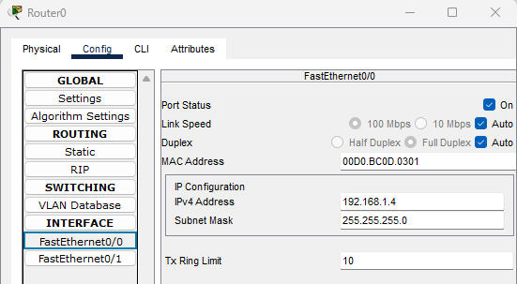
FastEthernet0/1
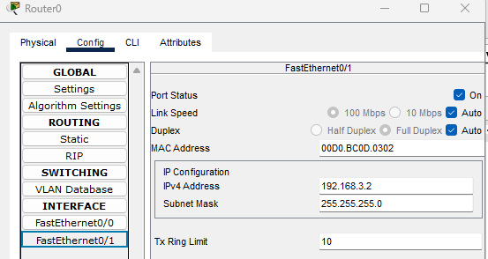
FastEthernet0/1 (Router 1)
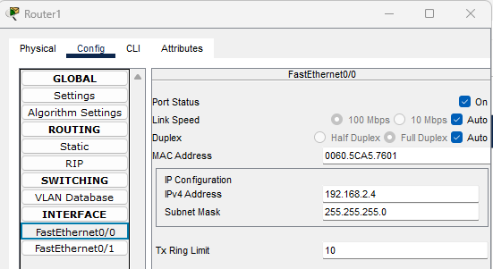
FastEthernet0/1
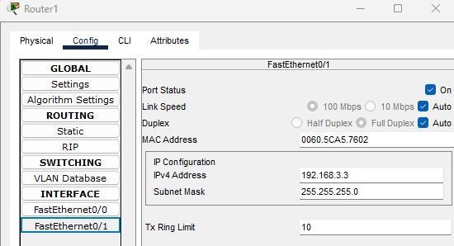
Commands:
Router 0
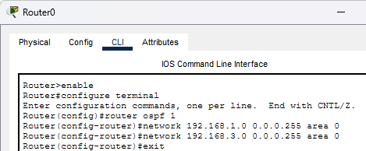
Router 1
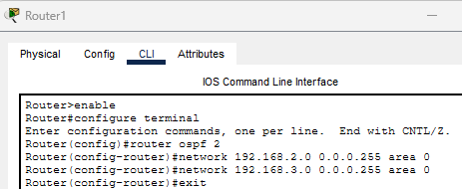

Practical No.16
Aim: Configure DHCP (Dynamic Host Configuration Protocol) Server.
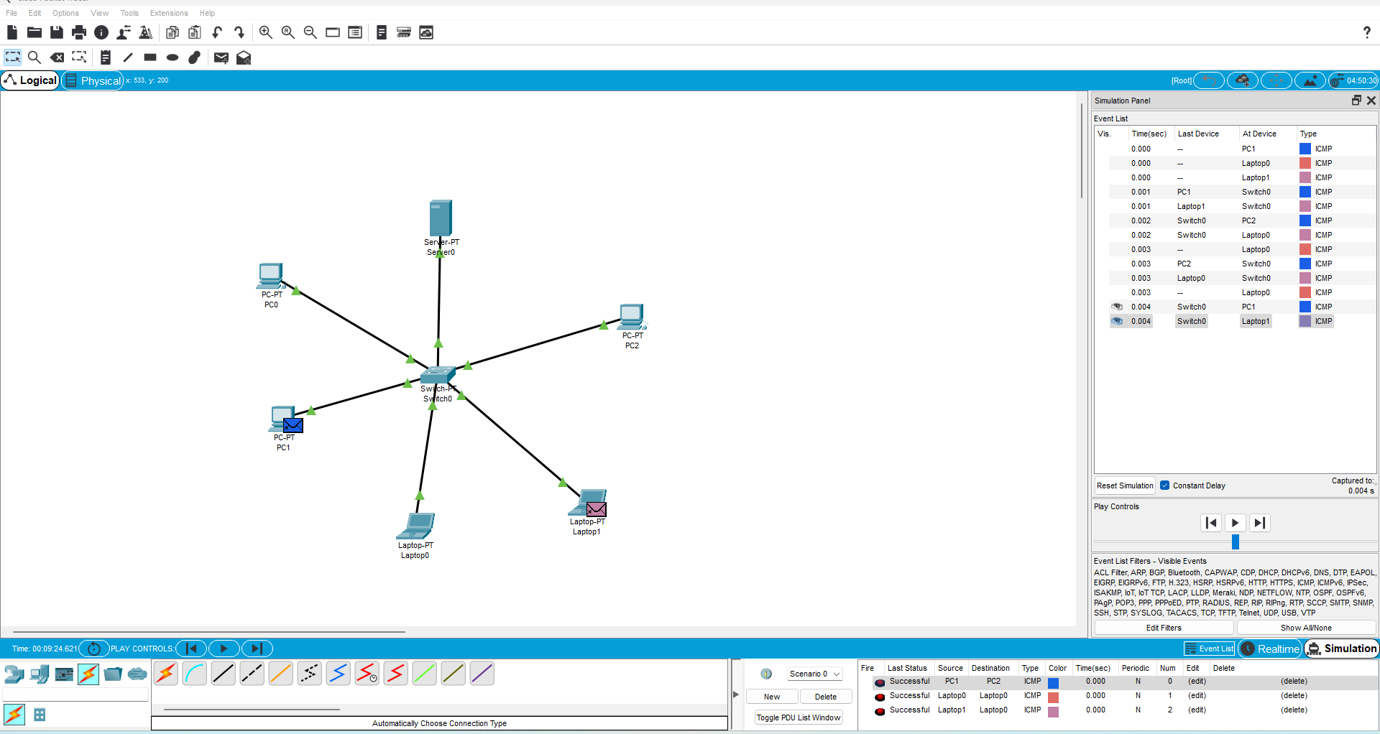
- Server
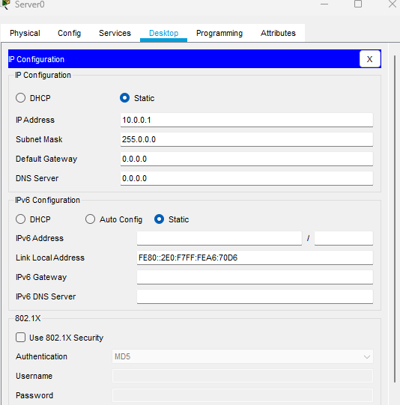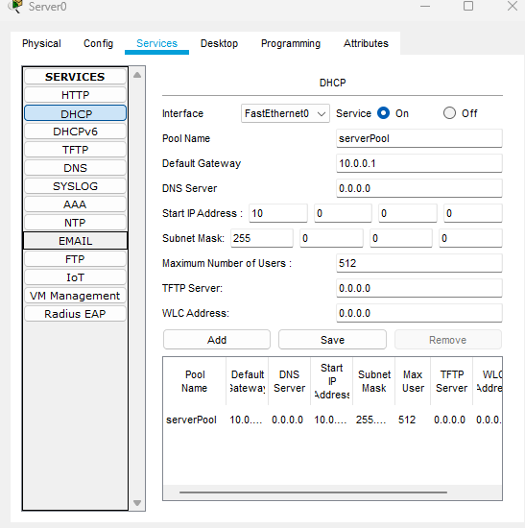

- PCs & Laptop
PC (1) PC(2)
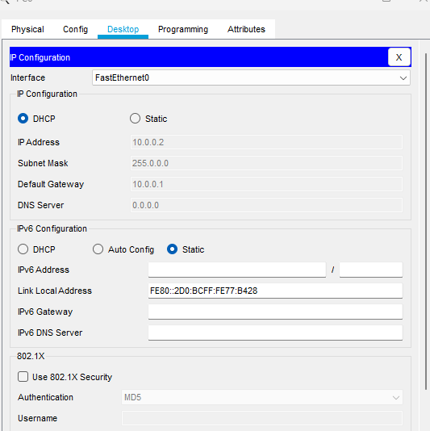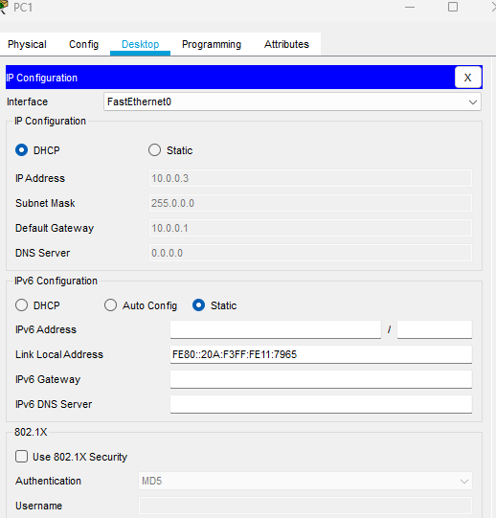
PC(3) Laptop(1)
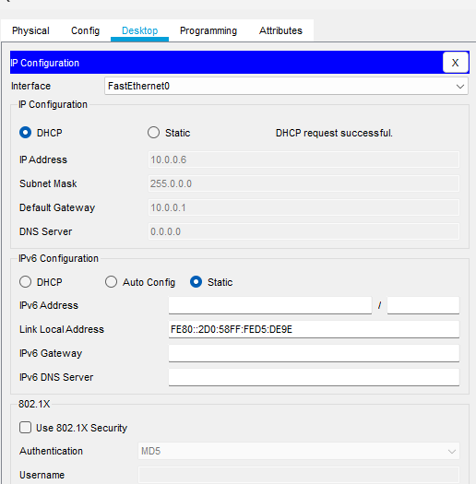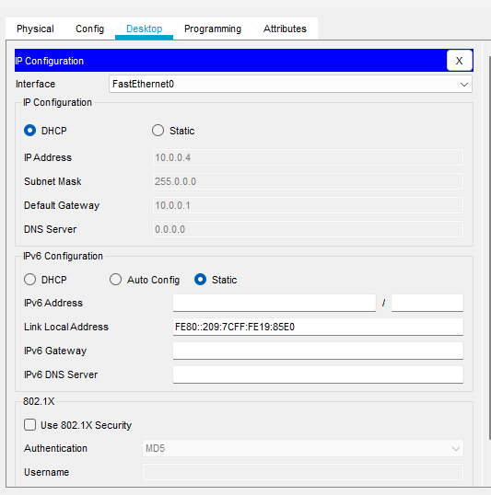

Laptop(2)
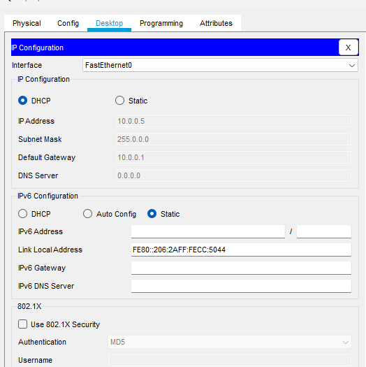

Practical No.17
Aim: Configure DHCP ( Dynamic Host Configuration Protocol) Client.
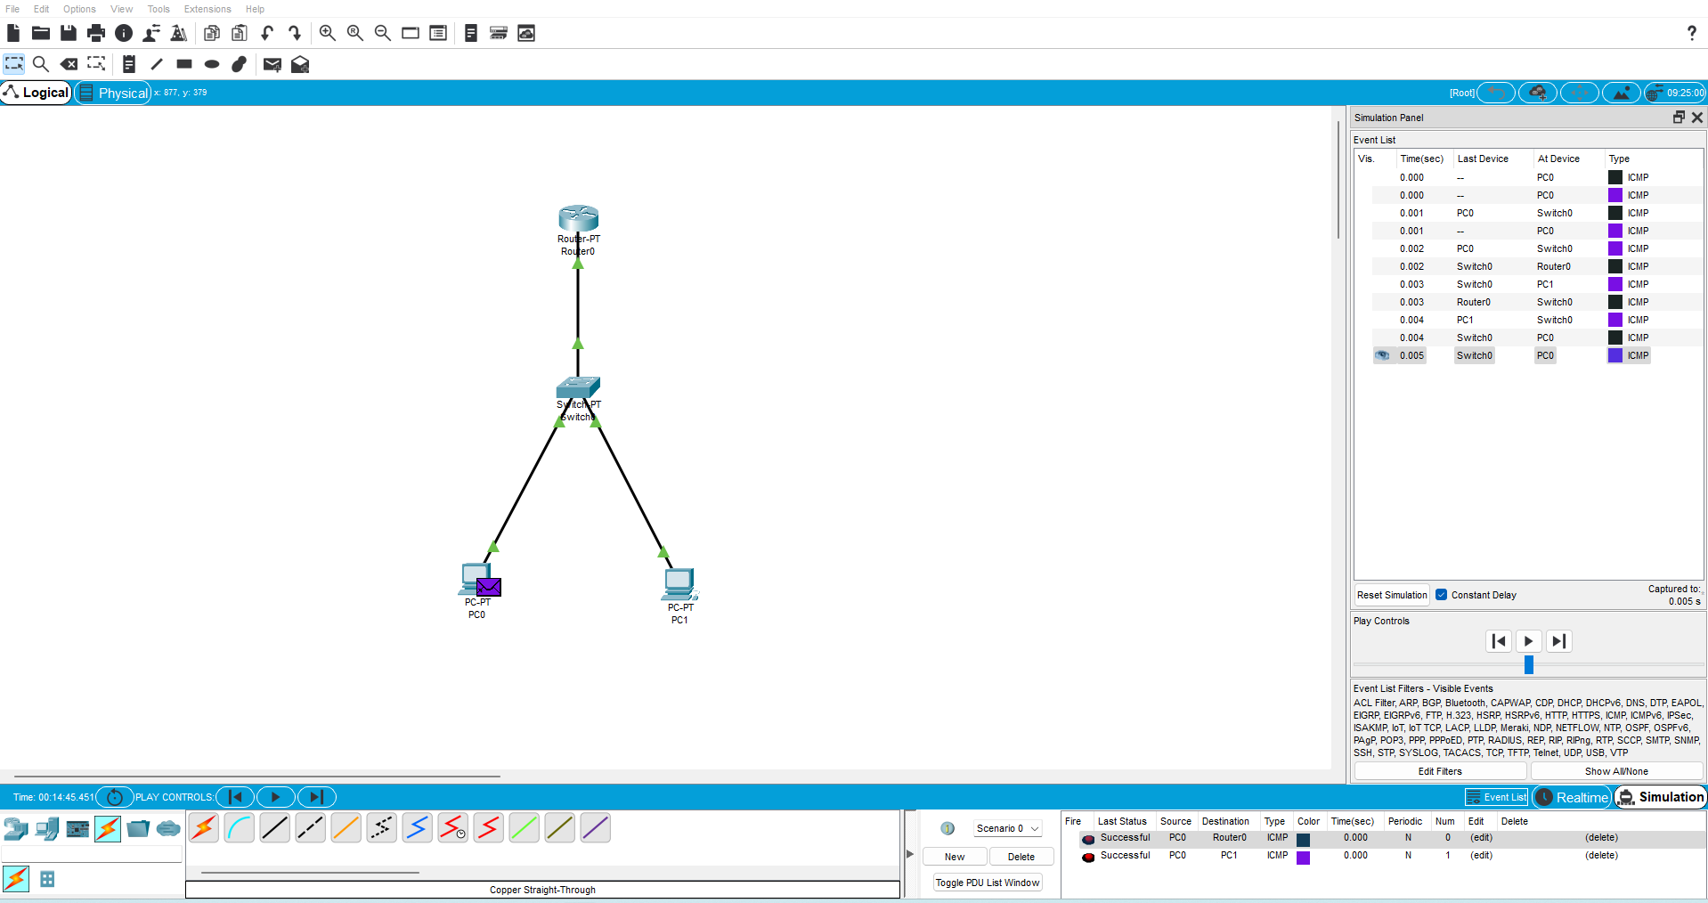

- Router
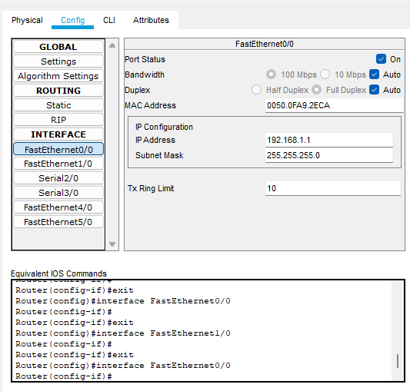

- PC 0
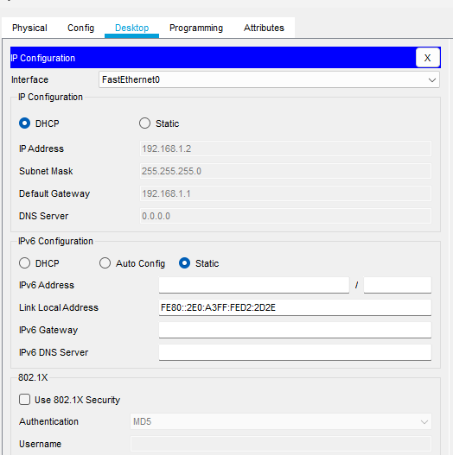
- PC 1
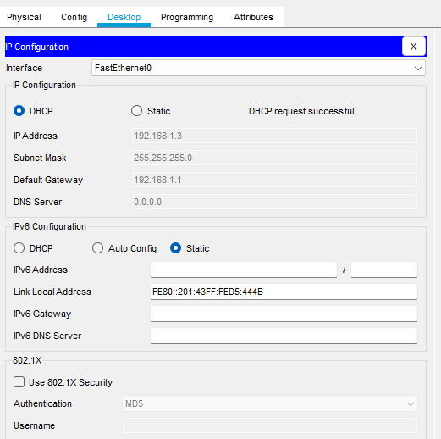

Practical No.18
Aim: Configure DNS (Domain Name System) Server.
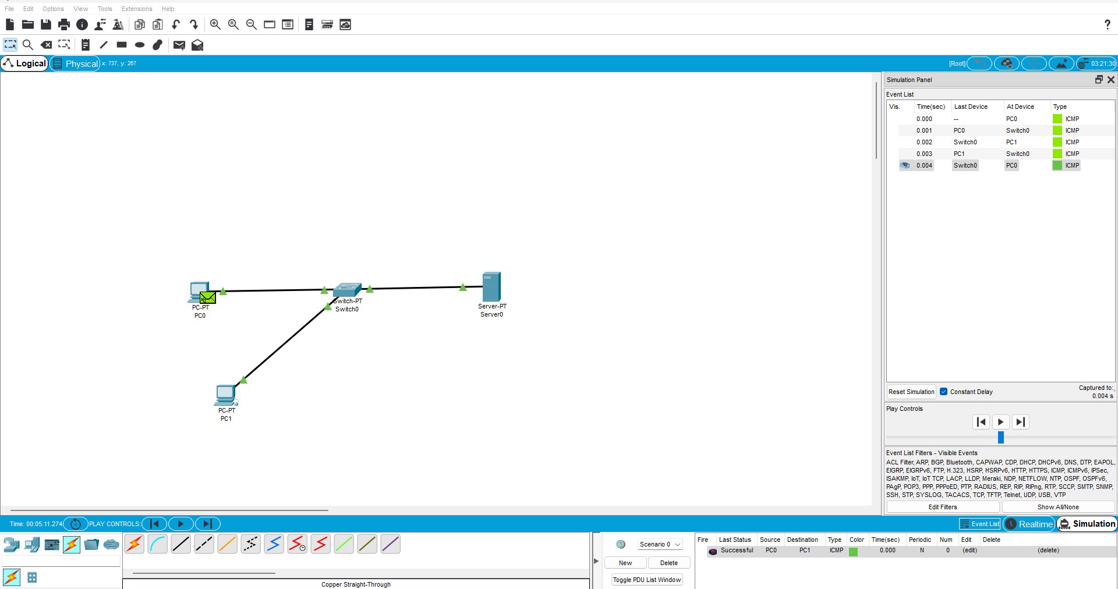

- Server
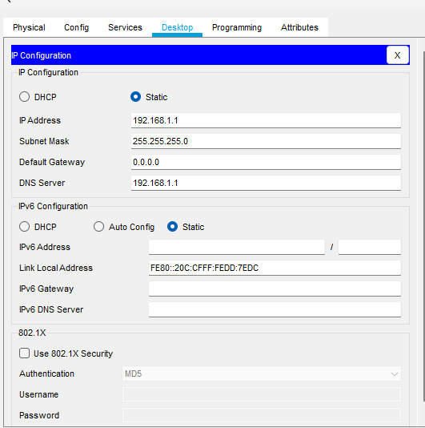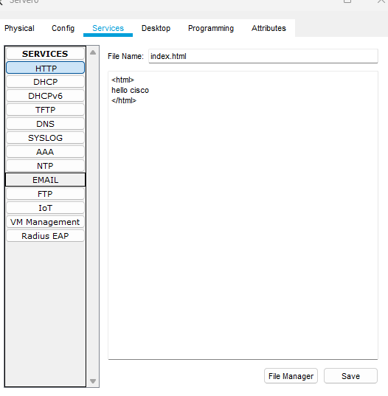
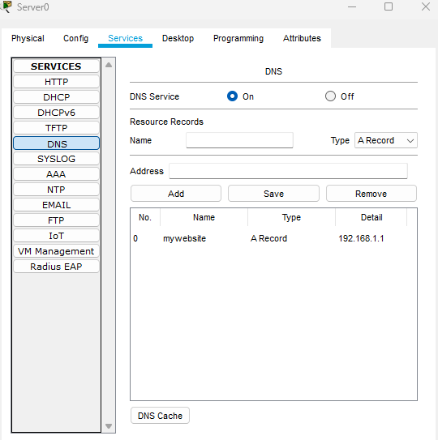

- PC(0) PC(1)
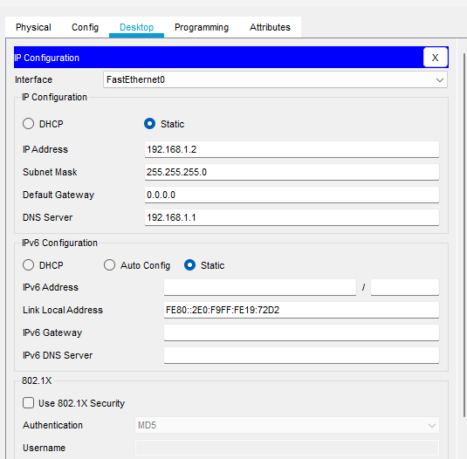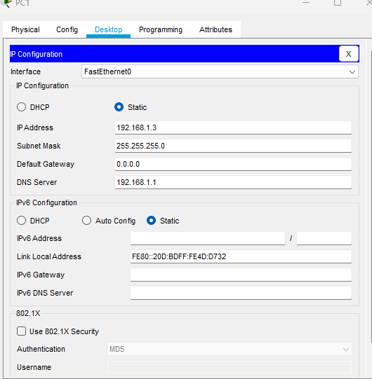

Practical No.19
Aim: Configuring DNS (Domain Name System) Client.
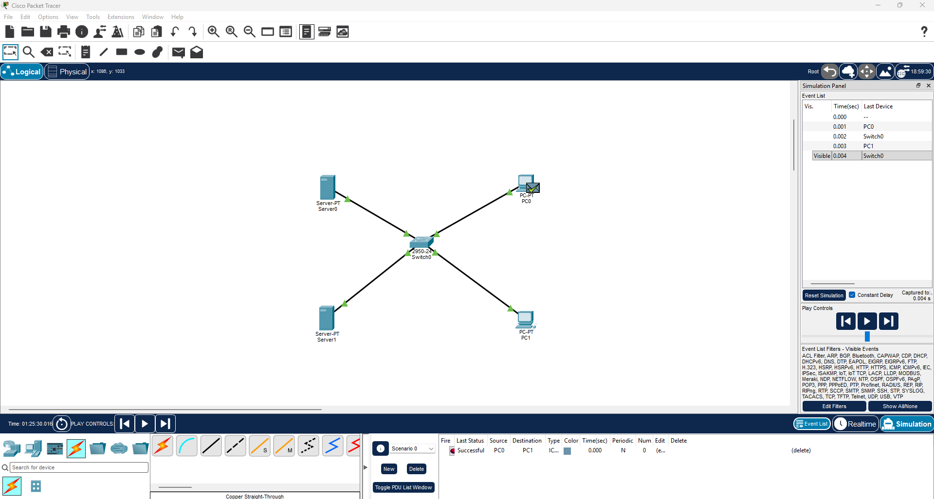
PC 0 PC 1
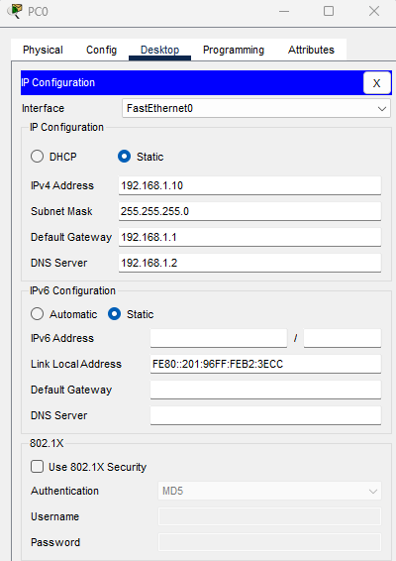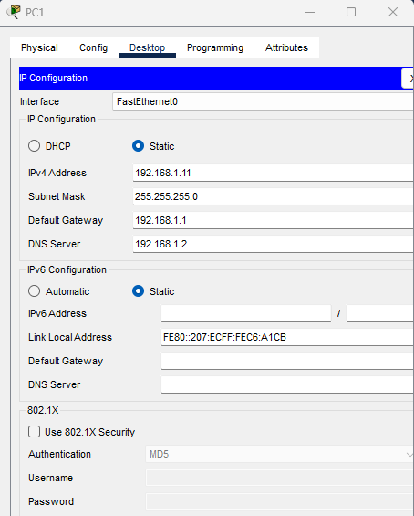

Server (DNS) Desktop
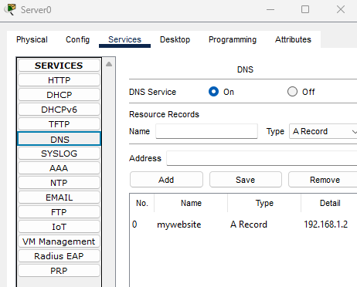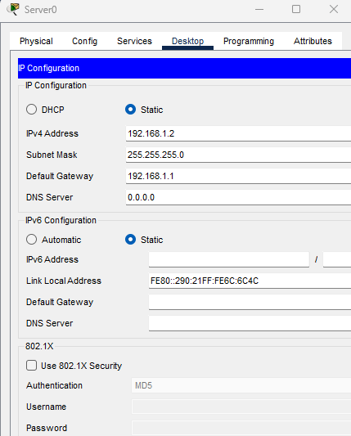

HTTP
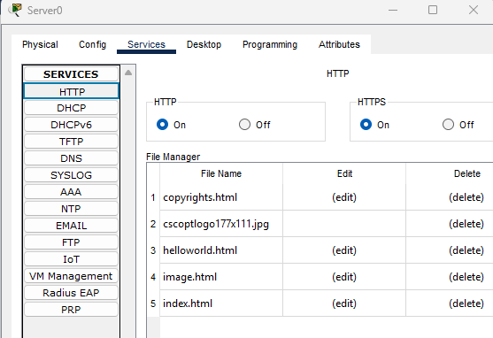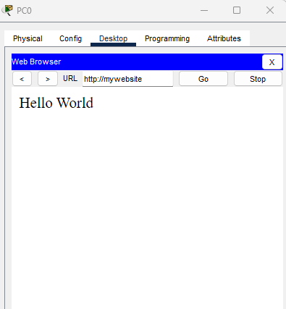

Practical No.21
Aim: Use of wireshark to scan and check the packet information of following protocol.
Wireshark is a free & open source network protocol analyzer. It is used to capture and examing network packets that are transmitted between computers and other network device when data travels through a network . It is divided into small units called packets. Wireshark capture packets and display their detail information allowing to understand what is happening on the network.
HTTP (Hypertext Transfer Protocol)
Protocols that enables communication and transfer of resources between web browsers and web servers.
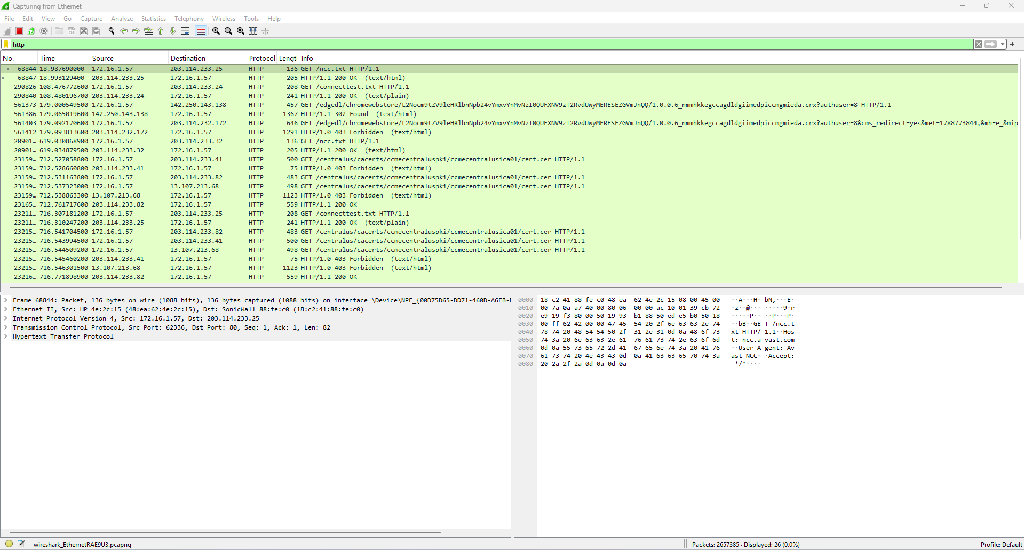

Practical No.22
Aim: Use of wireshark to scan and check the packet information of following protocol.
Wireshark is a free & open source network protocol analyzer. It is used to capture and examing network packets that are transmitted between computers and other network device when data travels through a network . It is divided into small units called packets. Wireshark capture packets and display their detail information allowing to understand what is happening on the network.

ICMP (Internet Control Message Protocol)
Used by network devices to send error message and control information about ip network communication.
OUTPUT:-

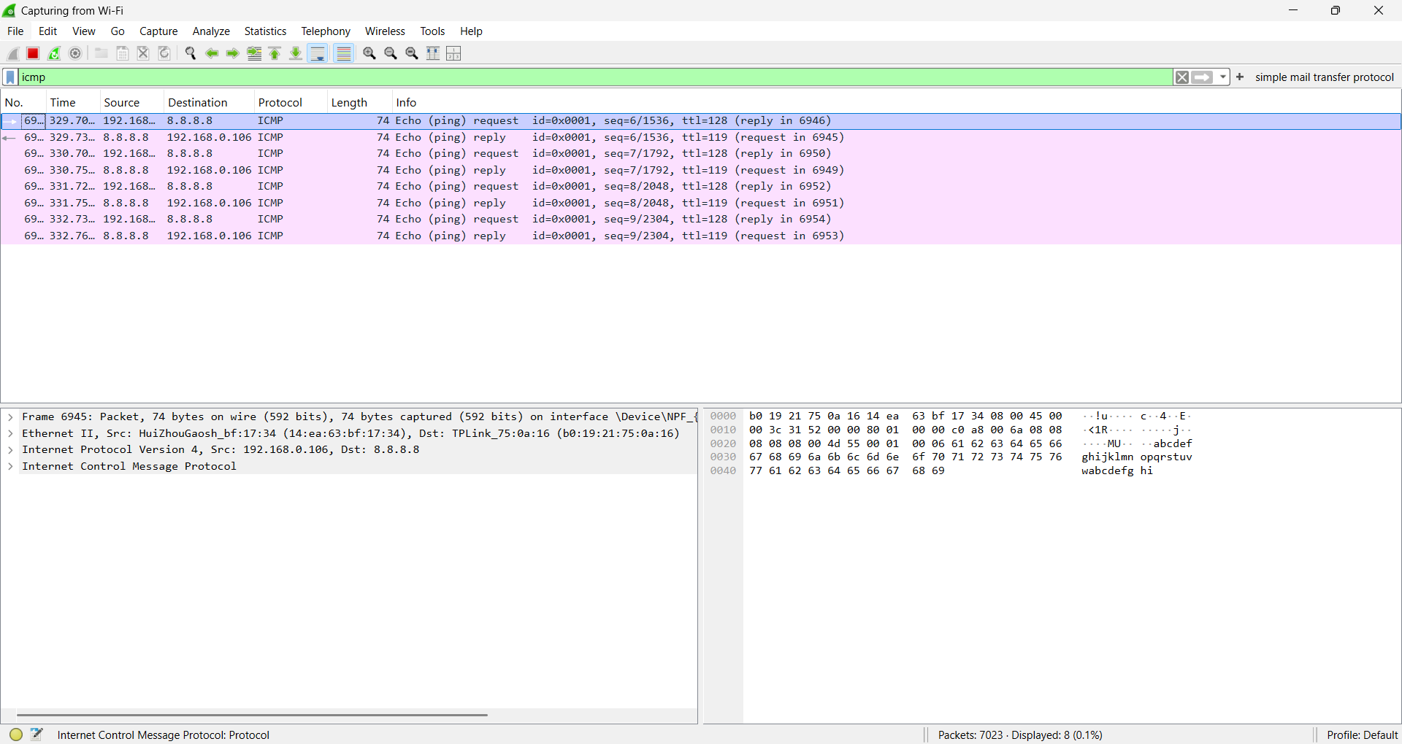
Practical No.23
Aim: Use of wireshark to scan and check the packet information of following protocol.
Wireshark is a free & open source network protocol analyzer. It is used to capture and examing network packets that are transmitted between computers and other network device when data travels through a network . It is divided into small units called packets. Wireshark capture packets and display their detail information allowing to understand what is happening on the network.

TCP (Transmission Control Protocol)
Used to provide reliable and ordered delivery of data between devices over a network.
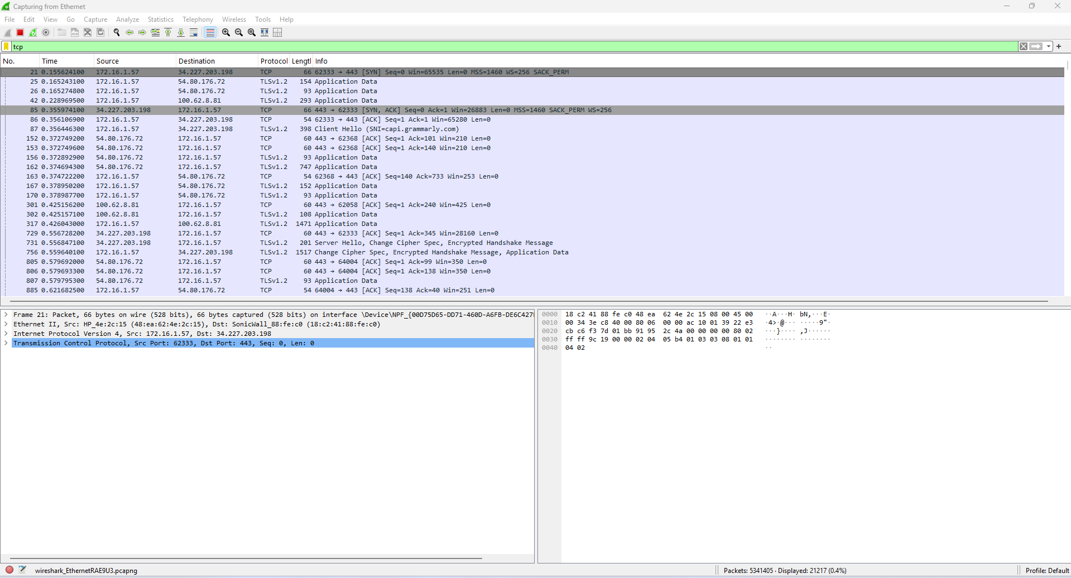

Practical No.24
Aim: Use of wireshark to scan and check the packet information of following protocol.
Wireshark is a free & open source network protocol analyzer. It is used to capture and examing network packets that are transmitted between computers and other network device when data travels through a network . It is divided into small units called packets. Wireshark capture packets and display their detail information allowing to understand what is happening on the network.

SMTP (Simple Mail Transfer Protocol)
Used to send and transfer emails from a sender to a mail server and between mail servers.
OUTPUT:-

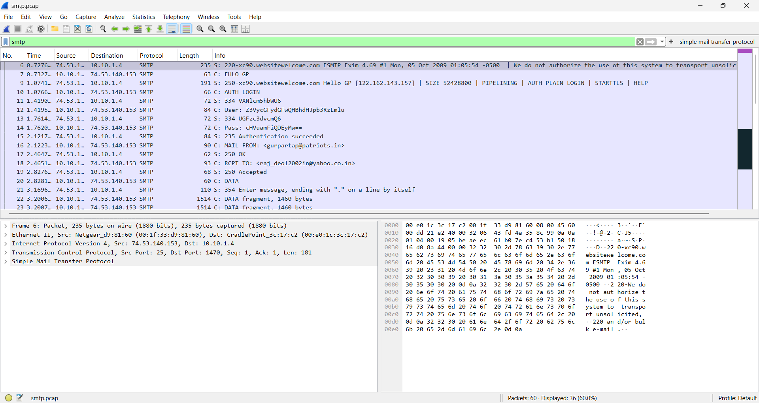
Practical No.25
Aim: Use of wireshark to scan and check the packet information of following protocol.
Wireshark is a free & open source network protocol analyzer. It is used to capture and examing network packets that are transmitted between computers and other network device when data travels through a network . It is divided into small units called packets. Wireshark capture packets and display their detail information allowing to understand what is happening on the network.

POP 3 (Post Office Protocol)
Used to receive emails from a mail server to an email client.

OUTPUT:-

